**API GateWay :**

**Step 1:** Create Rest API as shown in the image below, by clicking on Build button.

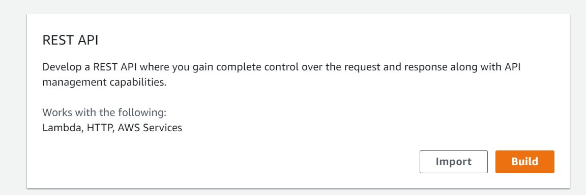

**Step2:** Create New API 🡪 select New API, and Enter API name of your API Gateway

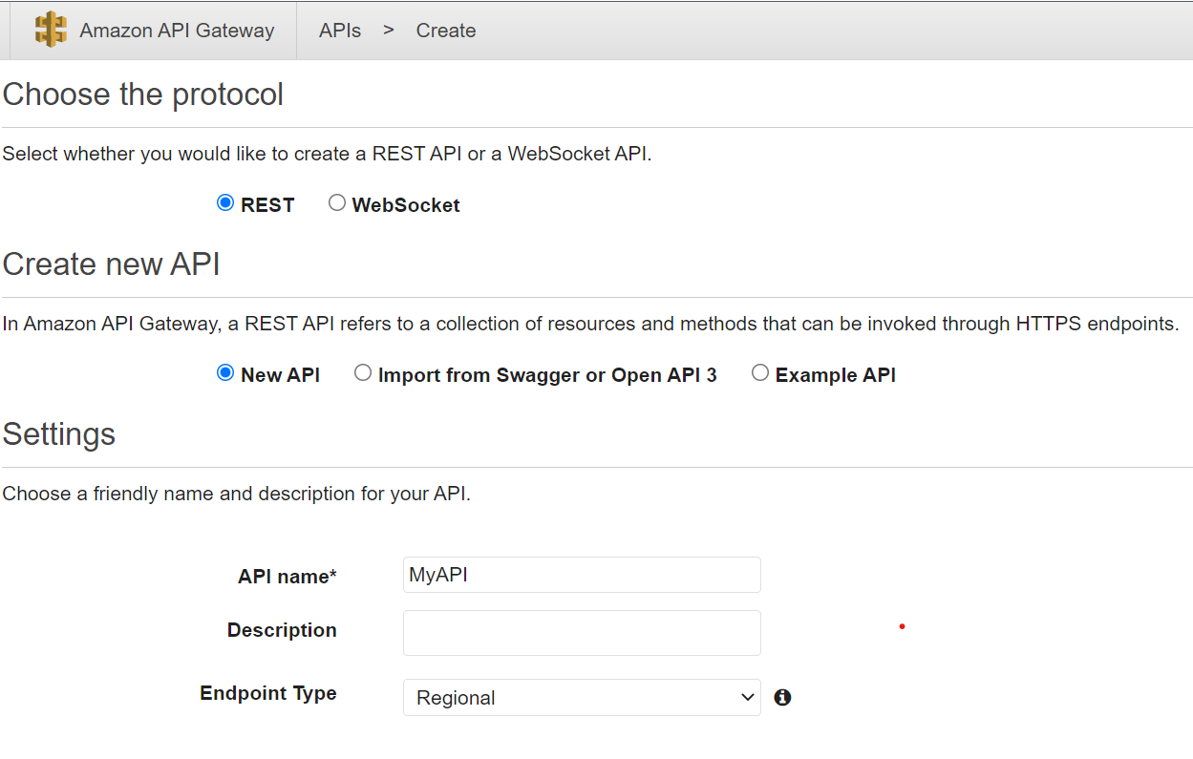

**Step3:**  Under the Actions button, Click on Create Resource to create a resource for end points.

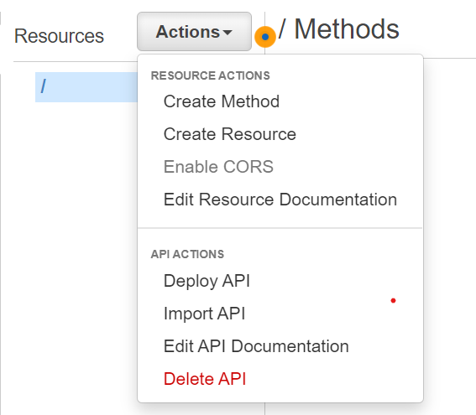

**Step 4:** Add your Resouce name and resource path as in mentioned in below.   
Resource Path: {resource-1} is used as dynamically. (with braces).  
Resource Path: resource-1 is used as static. (without braces).

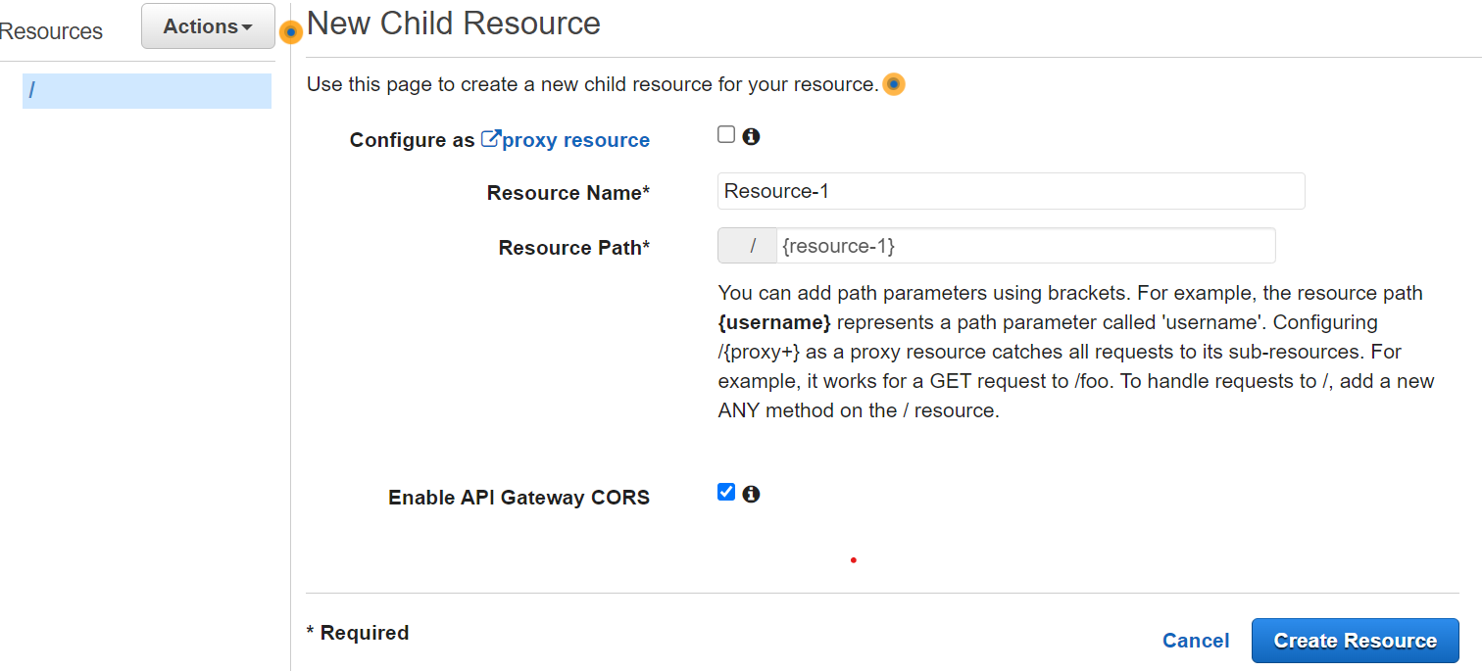

Click on Create Resource button below: Then resource-1 is created.

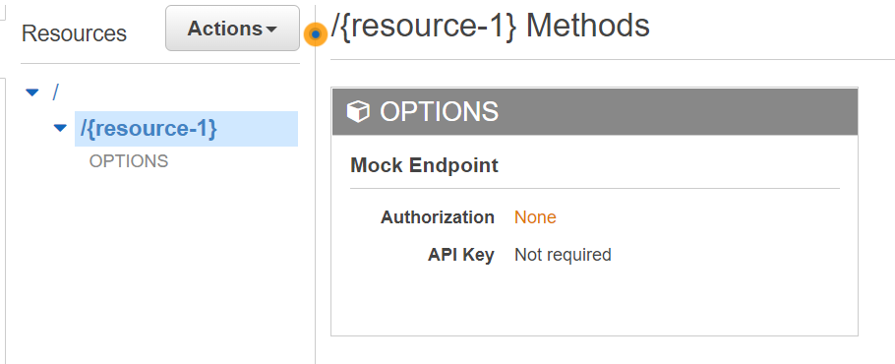

**Step 5:** Under Actions 🡪Create method for your api end points

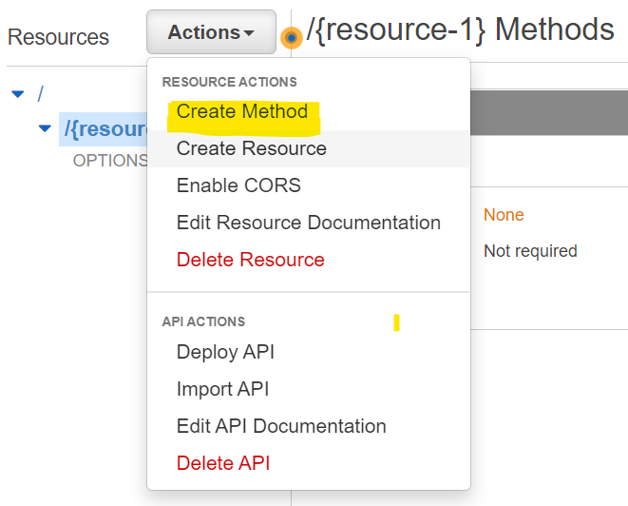

**Step 6:** Here adding GET method, Integration Type as HTTP, EndPoint URL should be EC2 instance end point with {resource-1}.   
Note: The value of resource-1 is any valid end point.

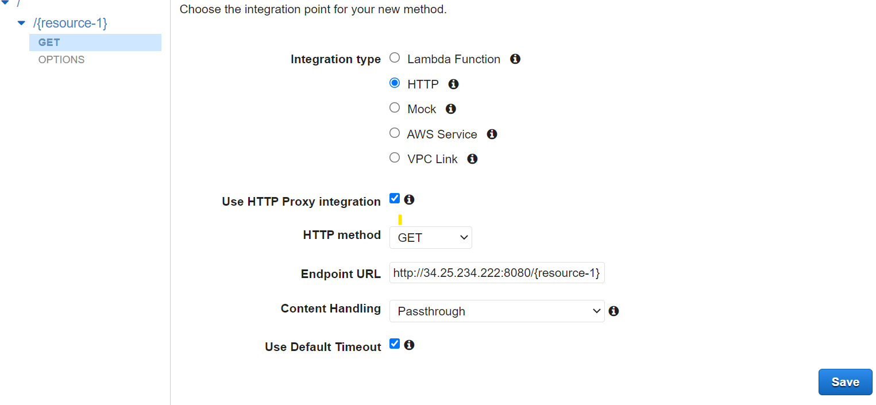

Click on Save. To create method.

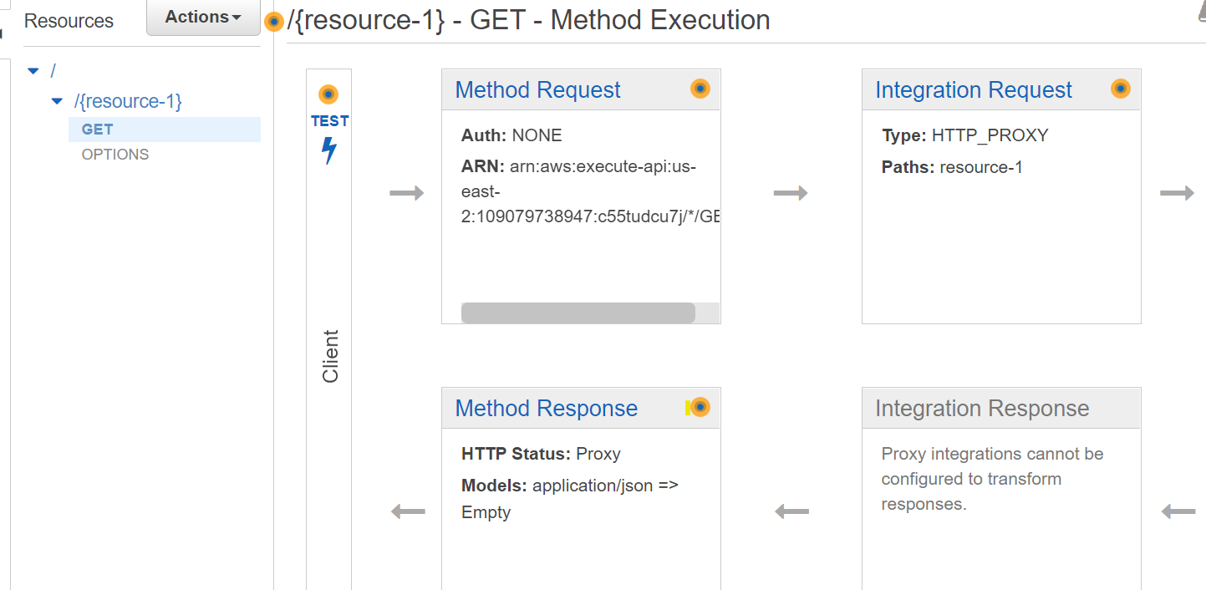

Click on Test to test your api’s by providing resource end points.